**Case-1**

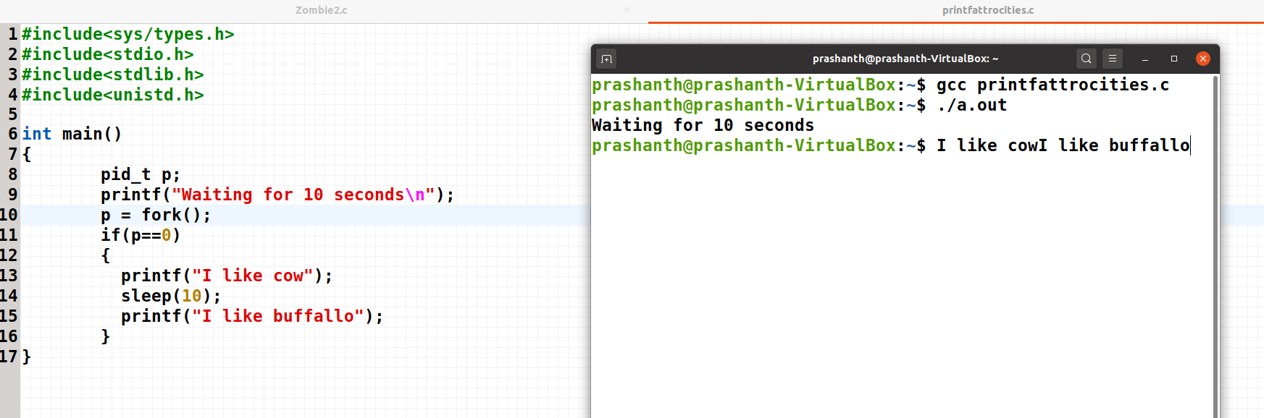

“I like cow” 🡪 Entering the buffer  
sleep(30)  
“I like buffalo” 🡪 Entering the buffer

Once the sleep finishes all are released from the buffer in the order they are added.

**Case-2:**

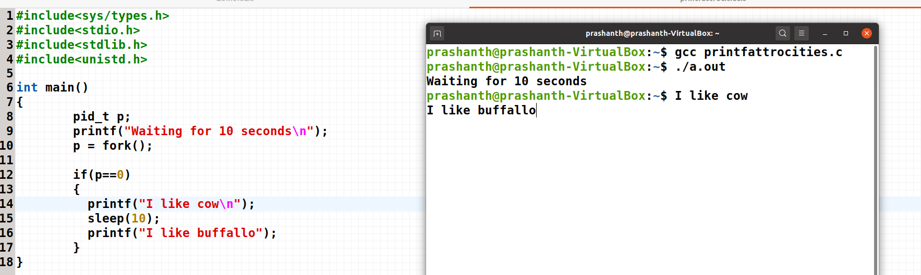

“I like cow” 🡪 Entering the buffer and after seeing “\n” , immediately exiting the buffer and printing before going to sleep.  
sleep(30)  
“I like buffalo” 🡪 Entering the buffer

Once the sleep finishes “I like buffalo” is released from the buffer and printed.

**Case-3:**

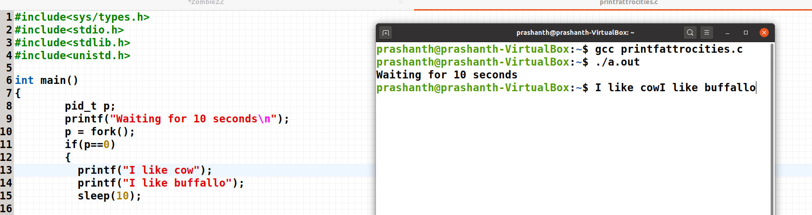

“I like cow” 🡪 Entering the buffer  
“I like buffalo” 🡪 Entering the buffer  
sleep(30)

Once the sleep finishes all are released from the buffer in the order they are added.

**Case-4:**

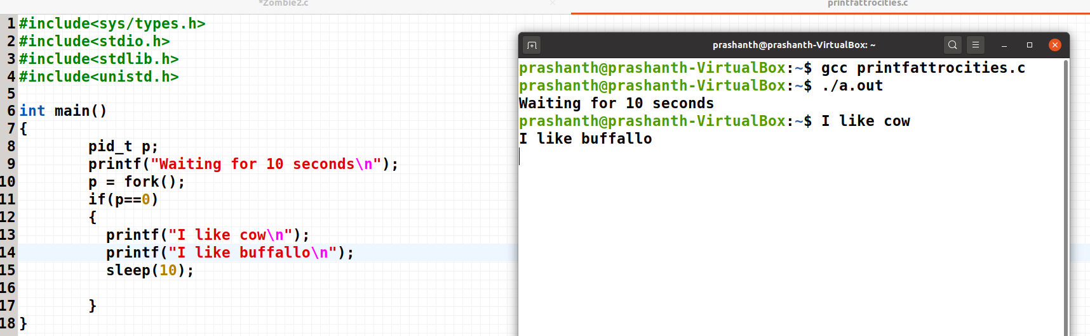

“I like cow” 🡪 Entering the buffer and after seeing “\n” , immediately exiting the buffer and printing  
“I like buffalo” 🡪 Entering the buffer and after seeing “\n” , immediately exiting the buffer and printing  
sleep(30)

There are no items in the buffer, since all the items in the buffer was printed before sleep was called.

**Conclusion:**

**print(“ \n”) 🡪 Works perfectly good**